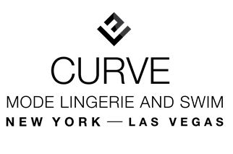
PERSONAL SHOPPER SURVEY

- How long have you been in business? / When are you expecting to launch?

- What brands do you currently carry in your store (If any)?

- What brands would you like to carry (if you know)?

- What product categories do you currently offer?

- Which categories (if any) would you like to add?

- How would you describe your store: look/feel/genre?

- What price point would you like to have?

- Who is your consumer? (Demographic)

- Any additional comments/notes about your boutique?

